IT RCSA Audit Documentation
Design of System – BSI.IT.23.C13
Design Assessment, Walkthrough and Sample of One (DH 3264 – Derivatives NDF) – re-performed with the 10/30/2026 evidence
DESIGN RATING | SAMPLE 3264 | CPA RATING | OBSERVATIONS
SATISFACTORY | PASS | SATISFACTORY | OBS-04, 05, 11

Control | BSI.IT.23.C13 – Design of System (Heracles ID 50541400) – Key, Manual, In every operation
Risk | BSI.IT.23.R4 Lack of Design Phase (Inherent Moderate)
Review period | 09/01/2025 – 08/31/2026 (Cycle 2, scheduled 10/01/2026 – 10/31/2026)
Test date / tester | 10/30/2026 – IT RCSA
Walkthrough | 08/05/2025 – Jose Luis Martinez Avial, Systems Development Director (prior cycle). 2026 confirmation with the control owner to be obtained in the 2026 walkthrough.
Sample of one | DH 3264 – Derivatives Non-Deliverable Forwards (NDF) – Releases 01 (prod 01/28/2026) and 02 (prod 05/08/2026)
Evidence folder | BSI.IT.23.C13 Design of System/Evidence (BSI.IT.23.C13.01 – C13.11; C13.05 – C13.11 new on 10/30/2026)

1. Design Effectiveness Summary
The control design is effective. The control is designed with an "In every operation" frequency, which is appropriate because every SDLC project/release must (i) complete a Data Risk Assessment (DRA) that the Chief Data Officer (CDO) reviews before the Gate 3 – Prepare to Plan (PTP) decision, and (ii) submit its Architecture Design artifacts (Single Design / Single Technical Design, Data Flow Guide) to Enterprise Architecture for approval and ARB determination before the Gate 5 – implementation decision. Both checkpoints occur before production, so the control prevents flawed or undocumented designs from being implemented (R4).
The nature of the control is manual: the Project Manager submits the artifacts, Enterprise Architecture approves by e-mail and the CDO records its participation / approval in the Delivery Hub gate disposition. Evidence is retained in Delivery Hub and can be obtained from the PMO.
HERACLES question | Answer | Rationale (2026)
1 Frequency / trigger | Yes | Triggered per SDLC project/release; DRA at Gate 3 and EA approval before Gate 5 – both before production.
2 Audit trail / evidence | Yes | DRA form + Gate 3 disposition (approval date, CDO In/Out) + EA approval e-mails in Delivery Hub (C13.03 – C13.11).
3 Policy alignment | Yes | Aligned with the SDLC process map step 1.3 (C13.01) and the US SDLC Standard; map v2.0 still Draft (OBS-01).
4 Thresholds | N/A | No threshold – applies to every SDLC project; DRA rating (Low/High) drives CDO participation.
5 Escalation | Full | Gate checkpoints per phase, monthly TWG status; PMO escalates missing EA confirmations before gates (C13.08, C13.09).
6 Information reliability | Moderately Reliable | Delivery Hub records and manual e-mail approvals; DRA approval date only visible on the gate record.
7 Evidence obtainable | Yes | Screens and documents downloaded from Delivery Hub by the PMO on request.

Design observations: OBS-01 – 2026 process map v2.0 still Draft (Date Approved / Approved By blank). OBS-04 – the control statement does not define when the EA approval must occur; in practice EA approves the design as a Gate 5 artifact, after the Gate 4 (PTB) start of Build. The 2026 proposed control statement in the Control Articulation Tracker requires approval "prior to the development phase" – if adopted, the EA review must move before Gate 4.

2. WT Summary
No 2026 walkthrough meeting was held for this cycle. The design understanding below is based on the walkthrough performed by IT RCSA on 08/05/2025 with Jose Luis Martinez Avial (Systems Development Director), the 2026 SDLC process map "2026 PM_Systems Development Life Cycle (BSI)_v1" (v2.0, Draft, 05/20/2026; Process Owner: Jose Luis Martinez; BCO: Elizabeth Noda) – which shows no change to the control – and the evidence received on 10/30/2026.
Model walkthrough language (RCSA CDA Job Aid §4.1): On 10/30/2026, IT RCSA performed a Test of One for BSI.IT.23.C13 through inspection of DH 3264 Derivatives NDF (Releases 01 and 02), selected from the Delivery Hub SDLC Project List for 09/01/2025 – 08/31/2026. The control is triggered by every SDLC project / release and performed in every operation by the Project Manager (submission), the Data Steward / CDO (DRA) and Enterprise Architecture (design approval). The tester reviewed the DRA (HIGH, CDO Approved), the Gate 3 (PTP) disposition (meeting 07/11/2025, approval 07/28/2025, CDO In) and the EA approval e-mails (12/10/2025 R01; 03/24/2026 R02), which demonstrate that design and data governance reviews were completed before production. The evidence is retained in Delivery Hub. When EA or CDO approval is missing, the gate is not approved and the PM escalates through the PMO / TWG. Additional iteration reviewed: DH 3263 Security Lending (DRA LOW – CDO Out). Based on the Test of One and evidence reviewed, no design deficiencies were identified; the control is appropriately designed to mitigate R4 because design and data risks are reviewed by the accountable functions before implementation.
Competency (Job Aid §4.4): based on prior-cycle inquiry and the 2026 evidence, the control owner / executor (Jose Luis Martinez Avial, BSI Development Director – IT Lead on both DRAs) and the PMs (Domingo Megia Planet, Marcus Medeiros) demonstrated an understanding of the gate artifacts, the ARB criteria and CDO participation rules, and obtained approvals from the accountable Enterprise Architect (Jofman Perez) before deployment. To be re-confirmed with the control owner in the 2026 walkthrough.

3. Sample of One – DH 3264 Derivatives NDF
Workpaper column | Value / conclusion | Evidence reference | Result
Sample ID | 2 (CPA row 54) | Workpaper CPA tab | Pass
Project ID / Name | 3264 – Derivatives Non-Deliverable Forwards NDF; type B3P; PM Megia Planet, Domingo; IT Lead Jose Luis Martinez Avial | C13.02; C13.04 | Pass
In scope (new system / customization) | T24 NDF module customization with Murex, Medea, 360, Bloomberg, DTCC integrations | C13.02; C13.10 | Pass
Architecture Design submitted to EA | RL1 Single Technical Design + Data Flow Guide sent 12/10/2025; RL2 sent 03/23/2026 | C13.10; C13.11 | Pass
EA approval prior to implementation | Approved 12/10/2025 (prod 01/28/2026) and 03/24/2026 (prod 05/08/2026); ARB criteria all "No" | C13.10; C13.11 | Pass
Data impact identified | Yes – existing KDE / non-KDE used in regulatory reporting; existing lineage impacted | C13.04 | Pass
DRA submitted / rating | Delivery Hub DRA – HIGH – "CDO: Approved" – Data Steward Miguel Menendez (BSI) | C13.04 | Pass
CDO approval prior to implementation | Gate 3 (PTP) meeting 07/11/2025, approval 07/28/2025, CDO = In | C13.06 | Pass
CDO-mandated data deliverables | Not provided separately – reliance on CDO gate approval and EA-approved Data Flow Guide | C13.06; C13.10 | Pass – OBS-05

Conclusion: For sample 3264 the Architecture Design artifacts were approved by Enterprise Architecture and the Data Risk Assessment was approved by the CDO before each production release. The sample passes. OI-02 from the 10/21/2026 draft is closed.

NewTest Script coverage (workpaper tab "New Test Script")
Step | Test script step | Sample of one – answer | Result
1 | Obtain Evidence | DRA, Gate 3 disposition and EA approvals obtained | Completed
2 | Completeness & Accuracy | 3264 traced to release tickets; independent release list not provided (OBS-11) | Pass – OBS-11
3 | Population & Scope | Customization with data impact – EA and CDO review both apply | Completed
4 | Control Execution | EA approved 12/10/2025 & 03/24/2026; DRA approved 07/28/2025 | Pass
5 | Control Results | Approvals by Enterprise Architect / CDO documented and dated | Pass
6 | Exception Handling | No exceptions; ARB not required (criteria all No) | Pass
7 | Escalation & Remediation | N/A – no exceptions | N/A
8 | Risk Mitigation | Design and data risks reviewed before production | Pass
9 | Testing Coverage | Documented in workpaper (2 projects / 4 releases) | Completed

Evidence references (BSI.IT.23.C13 folder)
Ref | Evidence | What it shows for 3264
C13.01 | 2026 PM_Systems Development Life Cycle (BSI)_v1.pdf | Step 1.3 "Architecture Design is developed" – control C13 (v2.0 Draft)
C13.02 | SDLC Project List (population).xlsx | 3264 – SDLC = Yes, T24, Closed 09/02/2026
C13.04 | NDF – Data Risk Assessment (CDO Approved, High).pdf | DRA rating HIGH, CDO: Approved (Exhibit A1)
C13.06 | NDF – DRA Approval and Gate 3 (PTP) disposition (new) | Gate 3 07/11/2025, approval 07/28/2025, CDO In (Exhibit A2)
C13.10 | NDF R01 – Single Technical Design sign-off EA 12-10-2025.msg (new) | Jofman Perez "Approved!" (Exhibit A3)
C13.11 | NDF R02 – Single Technical Design sign-off EA 03-24-2026.msg (new) | Jofman Perez "Approved"; RL2 no ARB applicability (Exhibit A3)

Appendix A – 3264 Evidence
Exhibit A1: Delivery Hub "Data Risk Assessment" – Project 3264 (BSI.IT.23.C13.06 / C13.04)
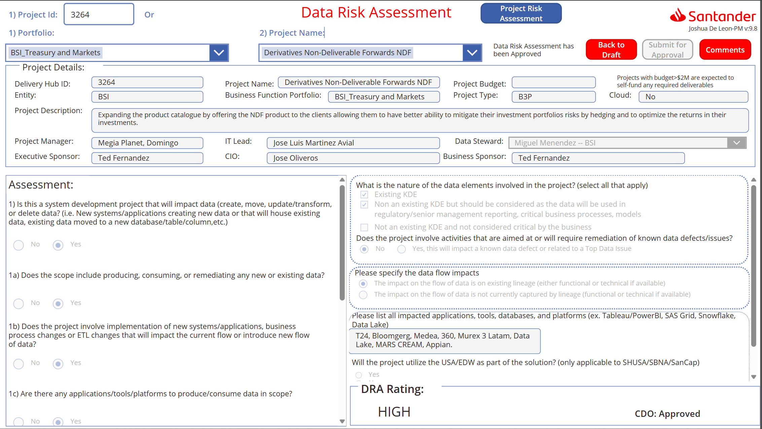
Source: BSI.IT.23.C13.06 – NDF DRA Approval.docx (image 1). DRA rating HIGH – CDO: Approved.
Exhibit A2: Delivery Hub "BSI Gate approvals (Waterfall)" – Project 3264
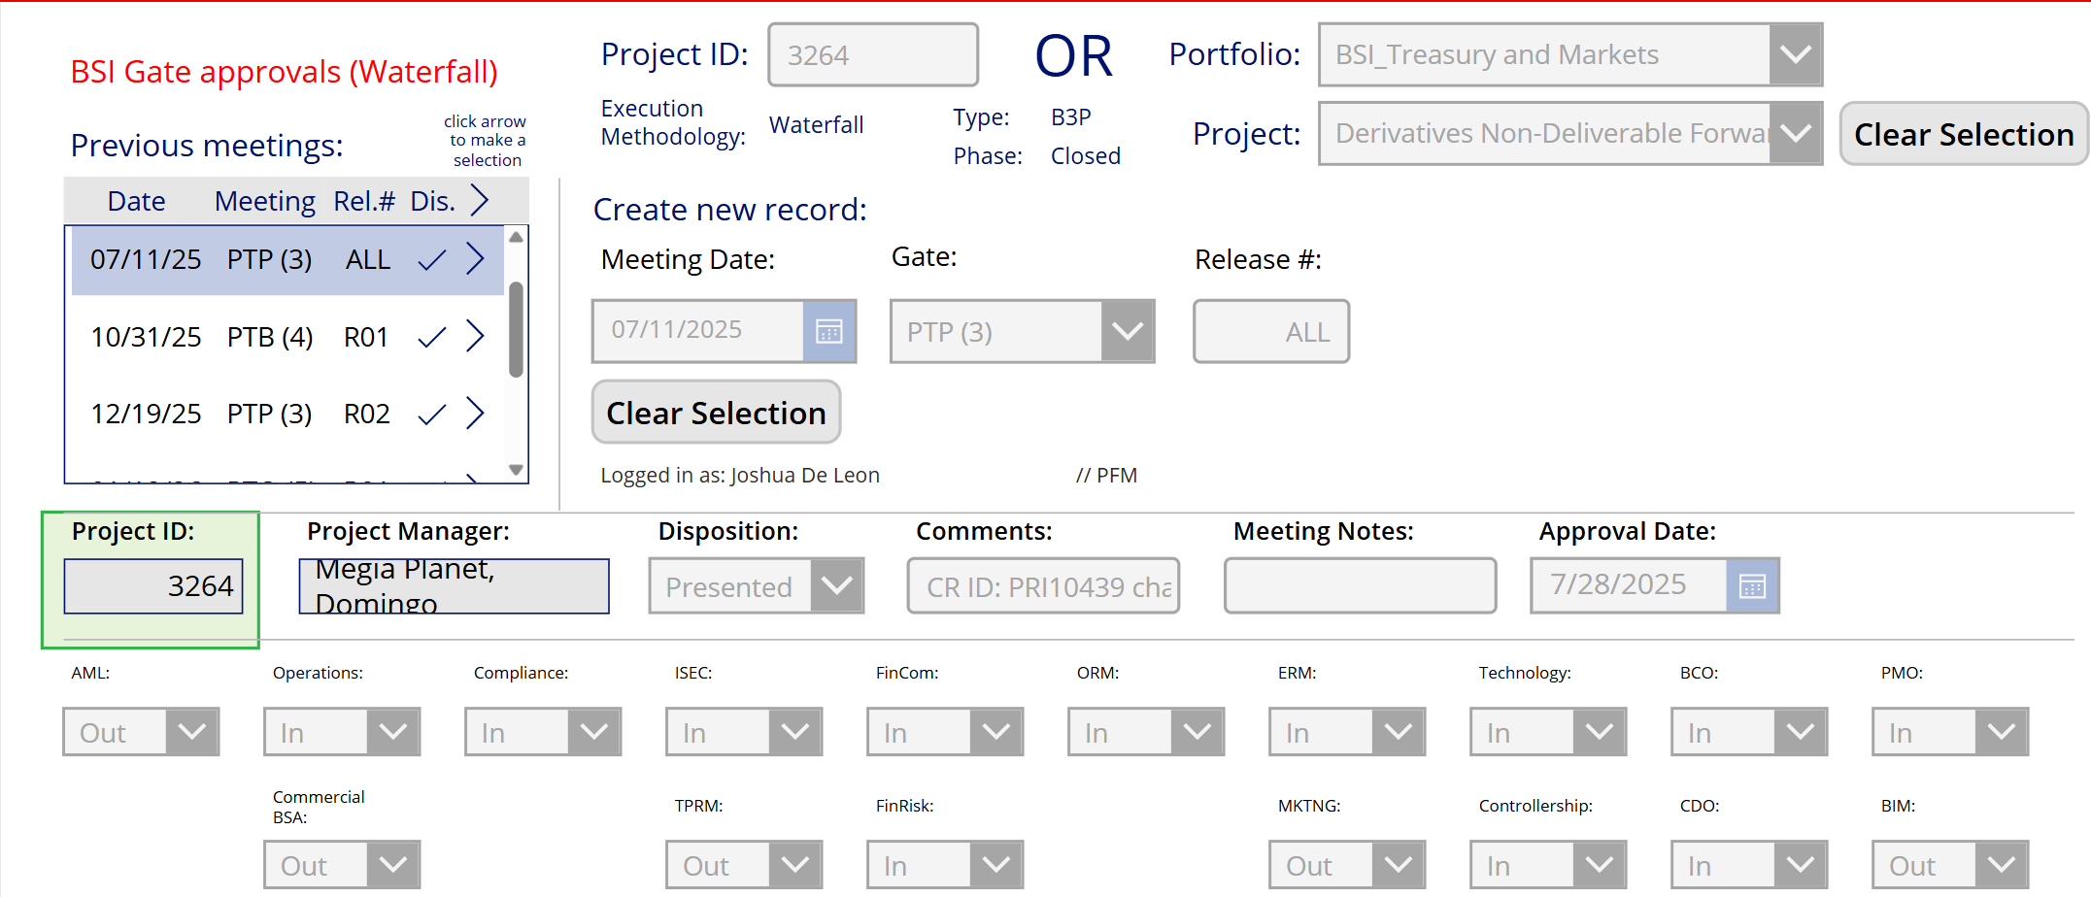
Source: BSI.IT.23.C13.06 (image 2). Gate 3 PTP 07/11/25 (ALL) – Disposition "Presented" (✓ in meeting list), Approval Date 7/28/2025, CDO: In; subsequent gates PTB(4) R01 10/31/25 and PTP(3) R02 12/19/25.
Exhibit A3: Enterprise Architecture approval e-mails (BSI.IT.23.C13.10, C13.11)
Field | RL1 (C13.10) | RL2 (C13.11)
Subject | Re: **Action Request"" – DH 3264 Derivatives OTC Customer Phase 1 (NDF) – Single Technical design | Re: **Action Request – DH 3264 … (NDF) – RELEASE 2 – Single Technical design
From → To | Jofman Perez (Enterprise Architect, VP) → Domingo Megia Planet; cc Ted Fernandez, Marcus Medeiros, Javier Nuño | Jofman Perez → Domingo Megia Planet; cc Ted Fernandez, Marcus Medeiros, Javier Nuño, IT Governance
Sent | 12/10/2025 12:55 PM ET (request 12/10/2025 3:30 AM) | 03/24/2026 8:17 AM ET (request 03/23/2026 7:41 AM)
Documents | RL1 Data Flow Guide_final; RL1 Single_Technical Design_final – Gate 5 artifacts | RL2 Data Flow Guide_final (unchanged); RL2 Single_Technical Design_final (slide 7 note)
Response | "Approved!" | "Approved" – RL2 no applicability to ARB; ISAR SAT-5256 / AST IS-25009 non-applicable

Referenced workbook: WP 2026 BSI.IT.23.C13 Design of System.xlsm – tab "Control Performance Assessment", row 54; tab "New Test Script".

